**TUTORIAL SHEET**

**SUBMITTED BY-Lalit Singh**

**IEC2020056**

**Q1. What will be the output of the following programs?**

a)

# include <stdio.h>

int main( )

{

int num[ 26 ], temp ;

num[ 0 ] = 100 ;

num[ 25 ] = 200 ;

temp = num[ 25 ] ;

num[ 25 ] = num[ 0 ] ;

num[ 0 ] = temp ;

printf ( "%d %d\n", num[ 0 ], num[ 25 ] ) ;

return 0 ;

}

**ANS) OUTPUT**

|  |
| --- |
| **200 100** |

b)

# include <stdio.h>

int main( )

{

int array[ 26 ], i ;

for ( i = 0 ; i <= 25 ; i++ )

{

array[ i ] = 'A' + i ;

printf ( "%d %c\n", array[ i ], array[ i ] ) ;

}

return 0 ;

}

**ANS) OUTPUT**

|  |
| --- |
| **2036624 1** |

c)

# include <stdio.h>

int main( )

{

int n[ 3 ][ 3 ] = {

2, 4, 3,

6, 8, 5,

3, 5, 1

} ;

printf ( "%d %d\n", n[ 3 ][ 3 ], n[ 2 ][ 2 ] ) ;

return 0 ;

}

**ANS) OUTPUT**

|  |
| --- |
| **1381254 1** |

**Q2. Attempt the following:**

**Twenty-five numbers are entered from the keyboard into an array. The number to be searched is entered through the keyboard by the user. Write a program to find if the number to be searched is present in the array and if it is present, display the number of times it appears in the array.**

**ANS)**

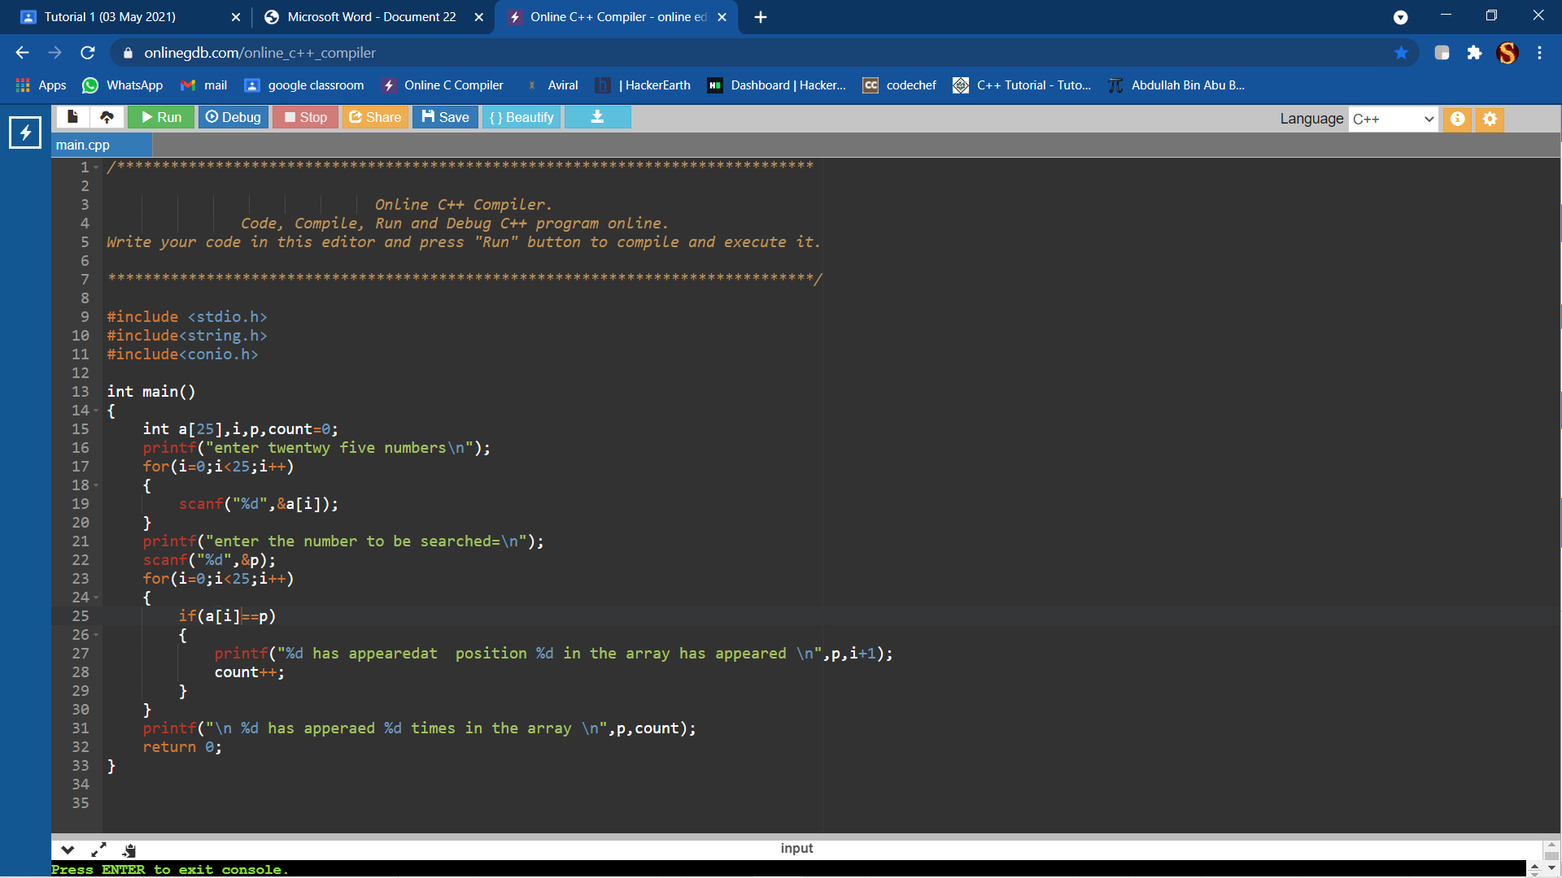

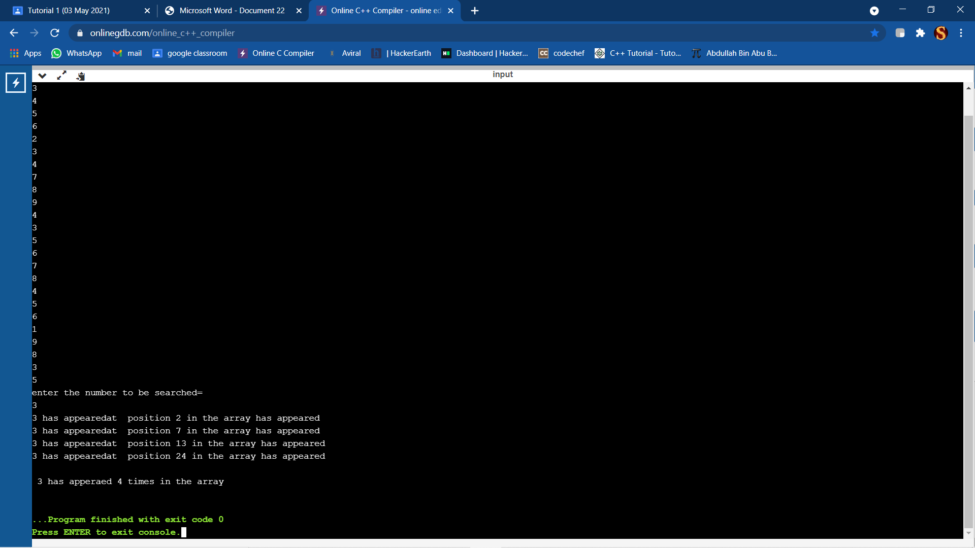

**Q3.Write a program to store and print the roll no. ,name , age and marks of a student**

**using structures.**

**ANS)**

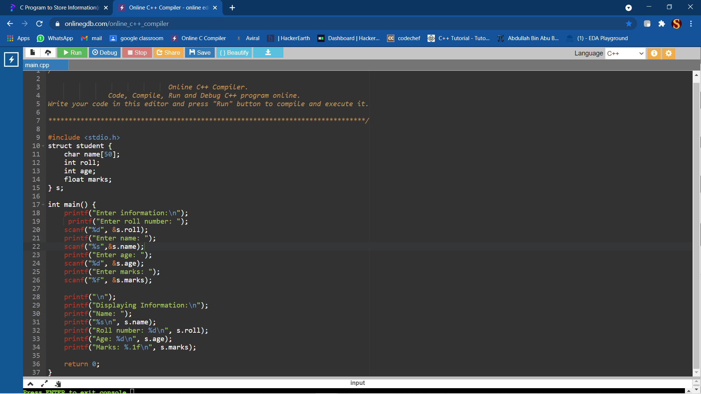

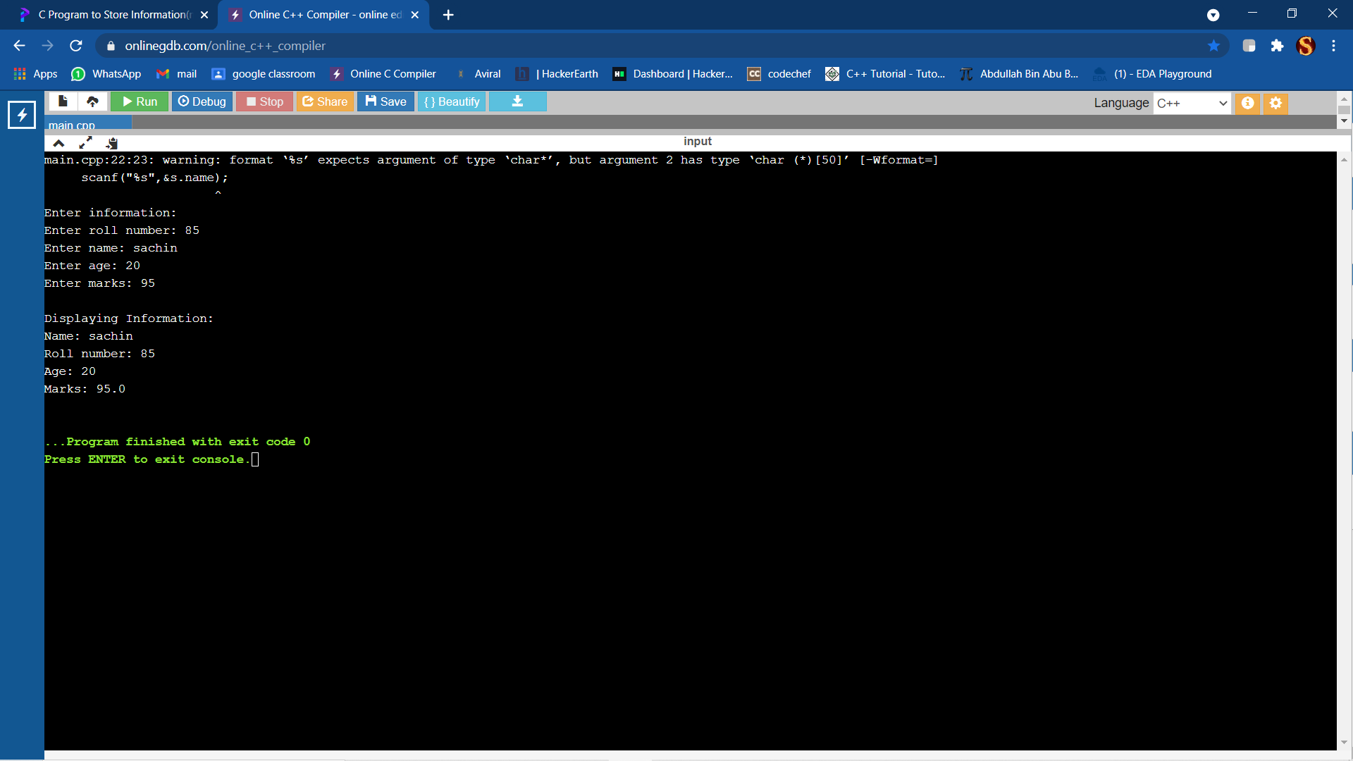

**Q4.Create a structure to specify data on students given below: Roll number, Name, Department, Course, Year of joining Assume that there are not more than 450 students in**

**the college.**

1. **Write a function to print names of all students who joined in a particular year.**

**ANS)**

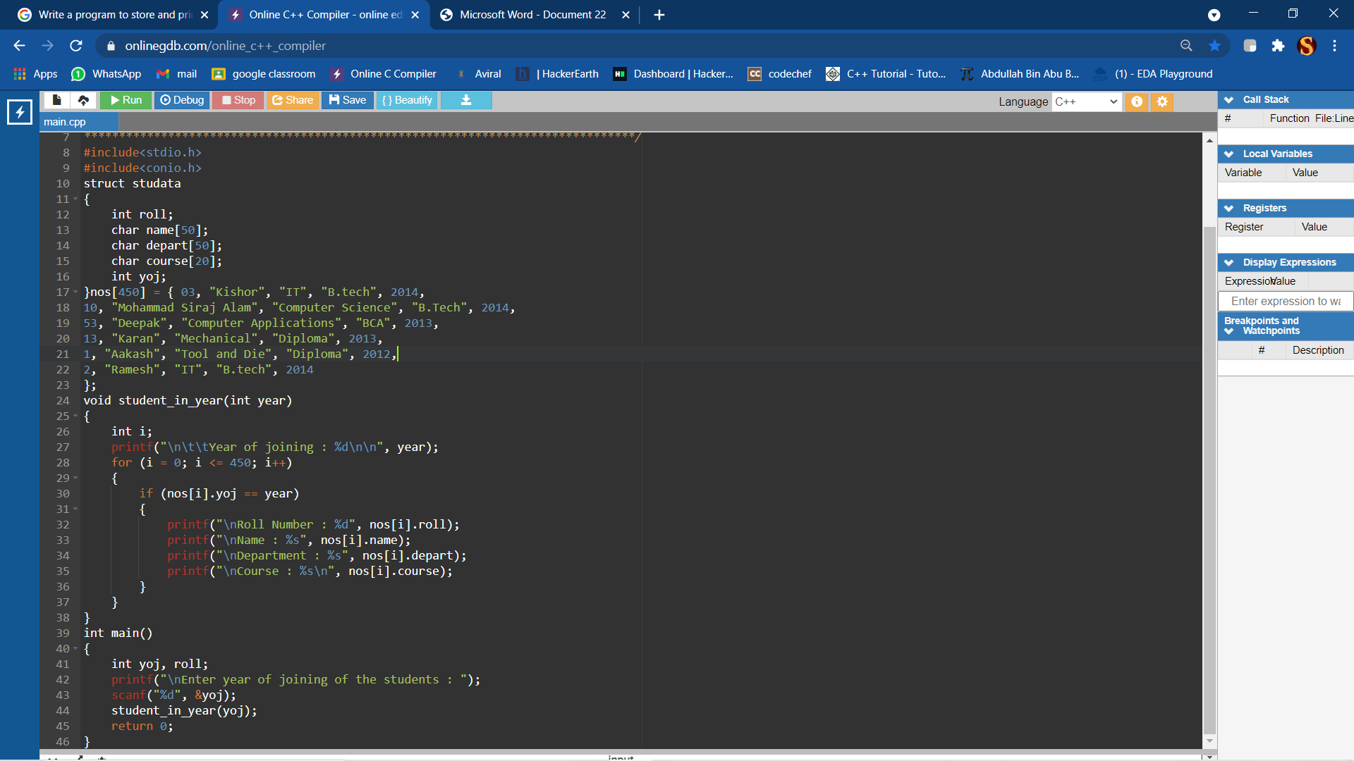

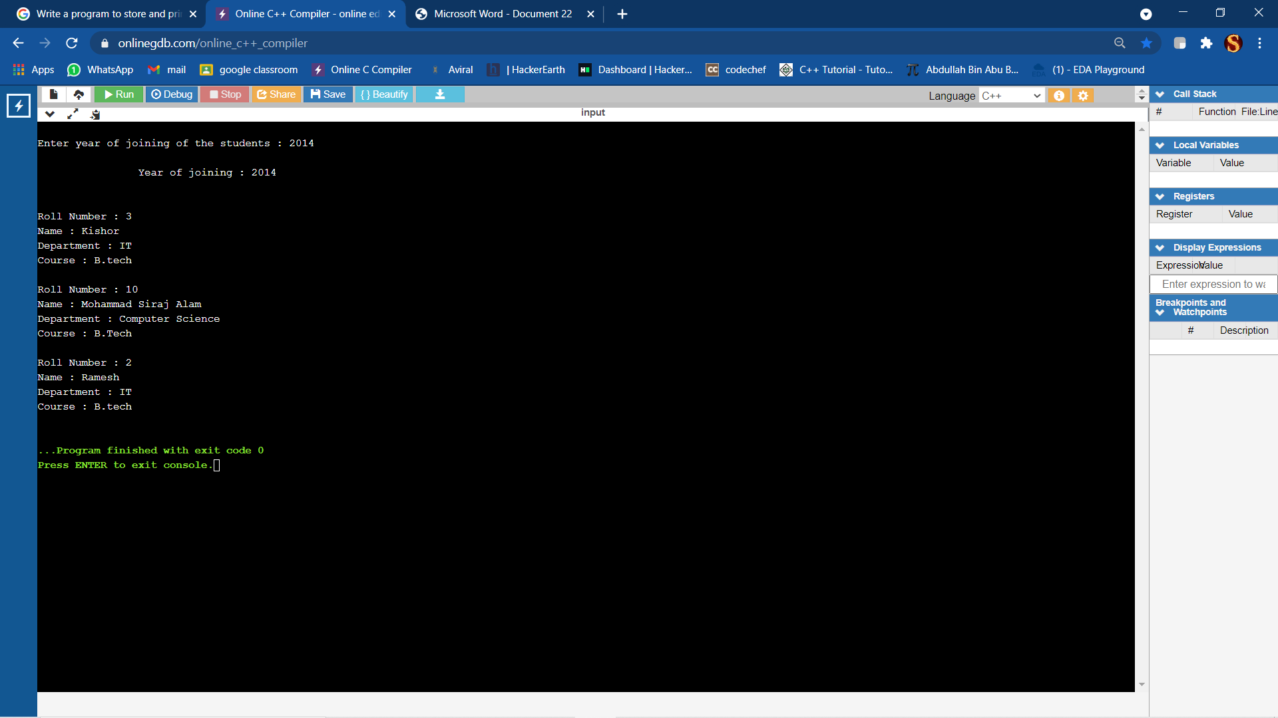

**Q5. If a variable is a pointer to a structure, then which of the following operators is used to access data members of the structure through the pointer variable?**

**Ans-**

To access data members of the structure through pointer variable arrow operator “->” is used.

**Q6. What will be the output of the following code assuming that array begins at location 1002?**

**Ans-**

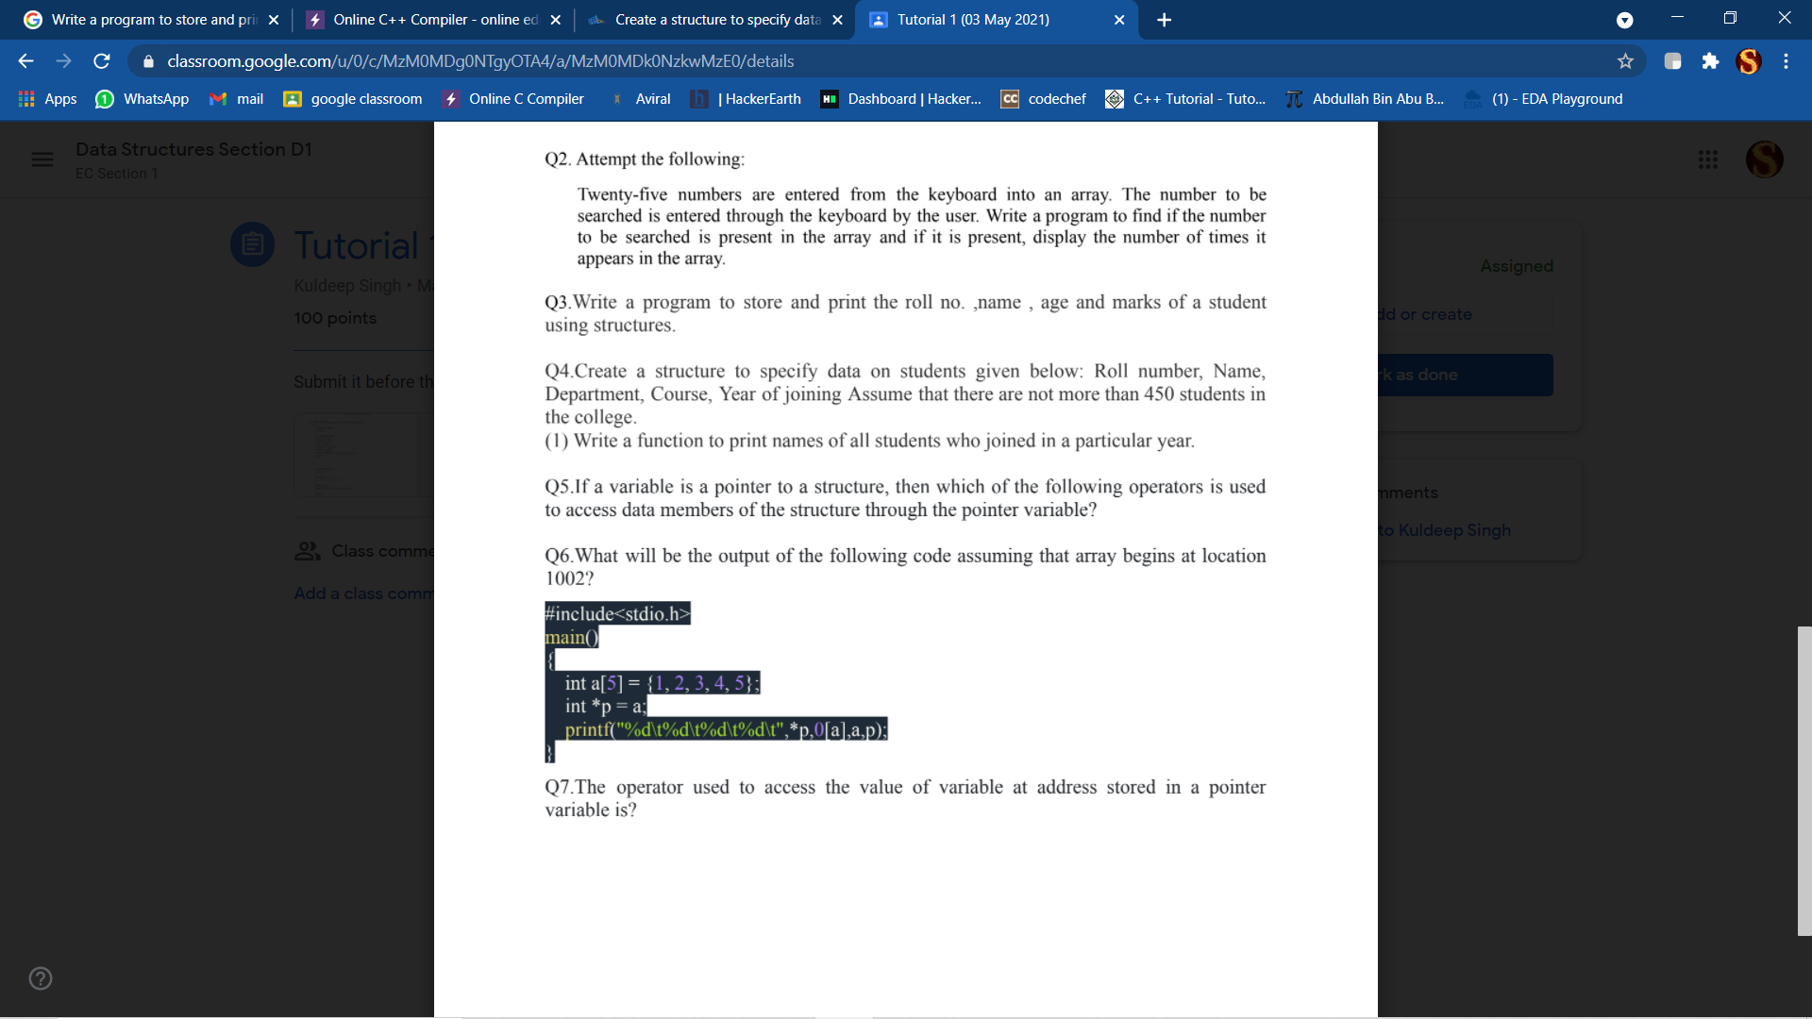

**OUTPUT**

1 1 1002 1002

**Q7.The operator used to access the value of variable at address stored in a pointer variable is?**

**Ans-**

The operator **“ * “** is used to access the value of variable at address stored in a pointer variable.